The goal of this project is to come up with a pricing model for ski resort tickets in our market segment. Big mountain suspected that we were not maximizing the returns relative to its position in the market. The correlation heatmap shows the correlation between all the facilities. First, summit and base elevation is highly correlated. You can also see that you've introduced a lot of multicollinearity with your new ratio features; they are negatively correlated with the number of resorts in each state. This latter observation makes sense. Turning your attention to your target feature, AdultWeekend ticket price, fastQuads stands out, along with Runs and Snow Making_ac.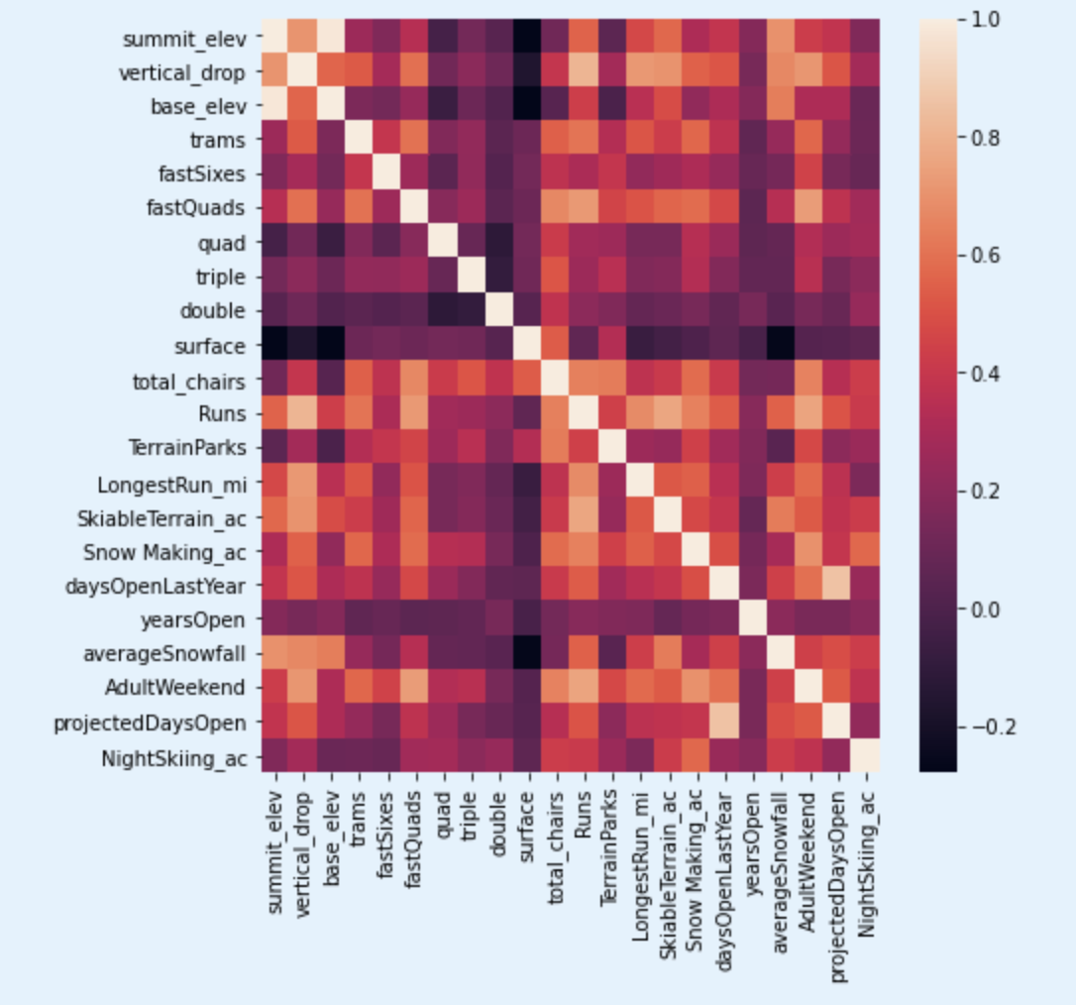

you see quite a few reasonable correlations. fastQuads stands out, along with Runs and Snow Making_ac. For sure, the total skiable terrain area is not as valuable as the area with snowmaking. People seem to put more value in guaranteed snow cover rather than more variable terrain areas.

The vertical drop seems to be a selling point that raises ticket prices. We confirmed our assumption by creating a Random Forest Model. This model is a very accurate model that only has a mean absolute error of 9.5377 and lower cross-validation mean absolute error by $1 meaning it has very less variability in predicting the ski prices. the model predicted $95.9 to be the price when the actual price is $81.00. Therefore, there is much room for an increase. We can just increase the ticket price to the expected price that the model made which was $95.9. However, since we have to think about the error the model can make which was $10.39, it is better to increase the price by only $8~$10. In addition, considering the resort operating in a market where people pay more for certain facilities, and less for others, we can sense how to support which facility and give up on some facilities. There are four scenarios that can enhance or deduct the pricing.

1. It is permanently closing down up to 10 of the least used runs. This doesn't impact any other resort statistics.
2. Increase the vertical drop by adding a run to a point 150 feet lower down but requiring the installation of an additional chair lift to bring skiers back up, without additional snow-making coverage
3. Same as number 2, but adding 2 acres of snow-making cover
4. Increase the longest run by 0.2 miles to boast 3.5 miles length, requiring additional snow-making coverage of 4 acres

The 1 scenario is not a great idea as you can see in Figure 1. It was a good idea considering to close the runs to lower the maintenance cost which will lead to having more money to save or use that money to maintain other facilities. However, it would not be a good case realistically.

Figure 1.

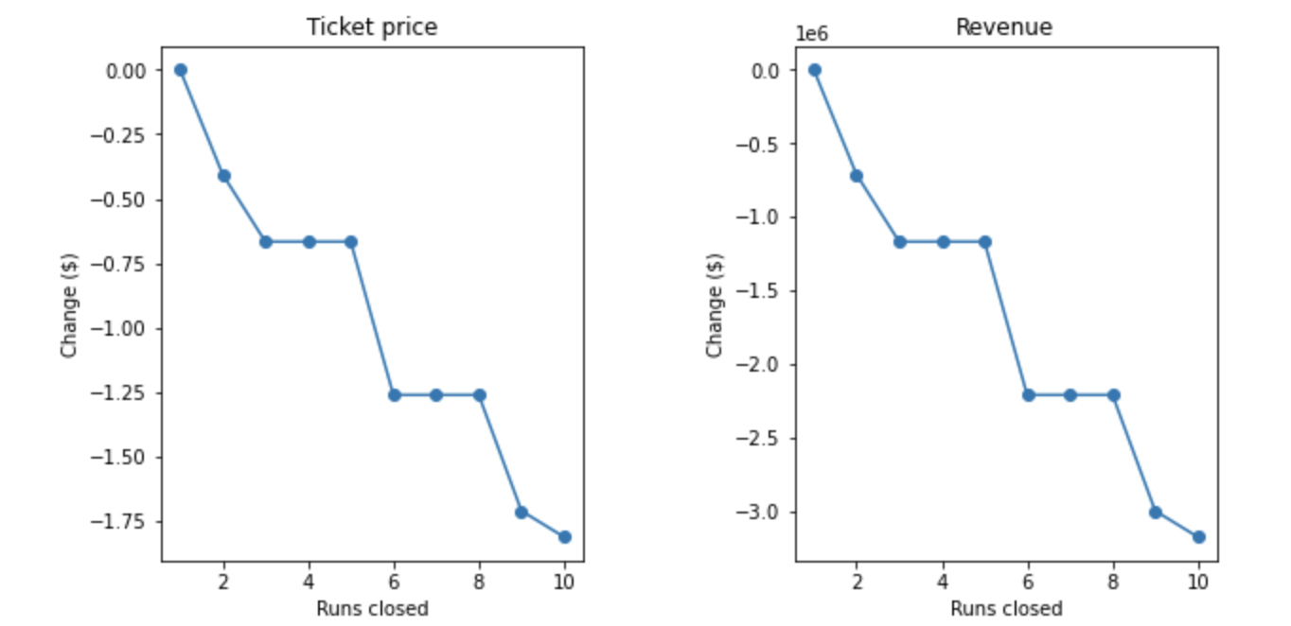

Scenario 2 would increase the vertical drop by 150 feet and installing an additional chair lift which would be increasing the ticket price by $1.99. The expected amount would be $3474638 over the season.

Scenario 3 would be the same scenario as scenario 2 but adding 2 acres of snow making resulting the same price increase and revenue as scenario 2.

Scenario 4 would not work because it does not change anything.

Therefore, increasing the vertical drop by 150 feet. installing an additional chair and adding 2 acres of snow making would result to increase the ticket price as $3.98 over the season which would become $6949275.